B.suhani

2403A5142

Batch-11

AI-ASSISTED-CODING

LAB-EXAM-2

**Q)D1**

**Context:**

The real estate listings platform data pipeline versions outputs with `_vNN`.

**Task:**

Implement bump_version(name) with tests; add/increment 2-digit suffix

**Data & Edge Cases:**

Preserve extension; handle files with/without suffix.

**Prompt:**

Generate for regex and edge-case tests.

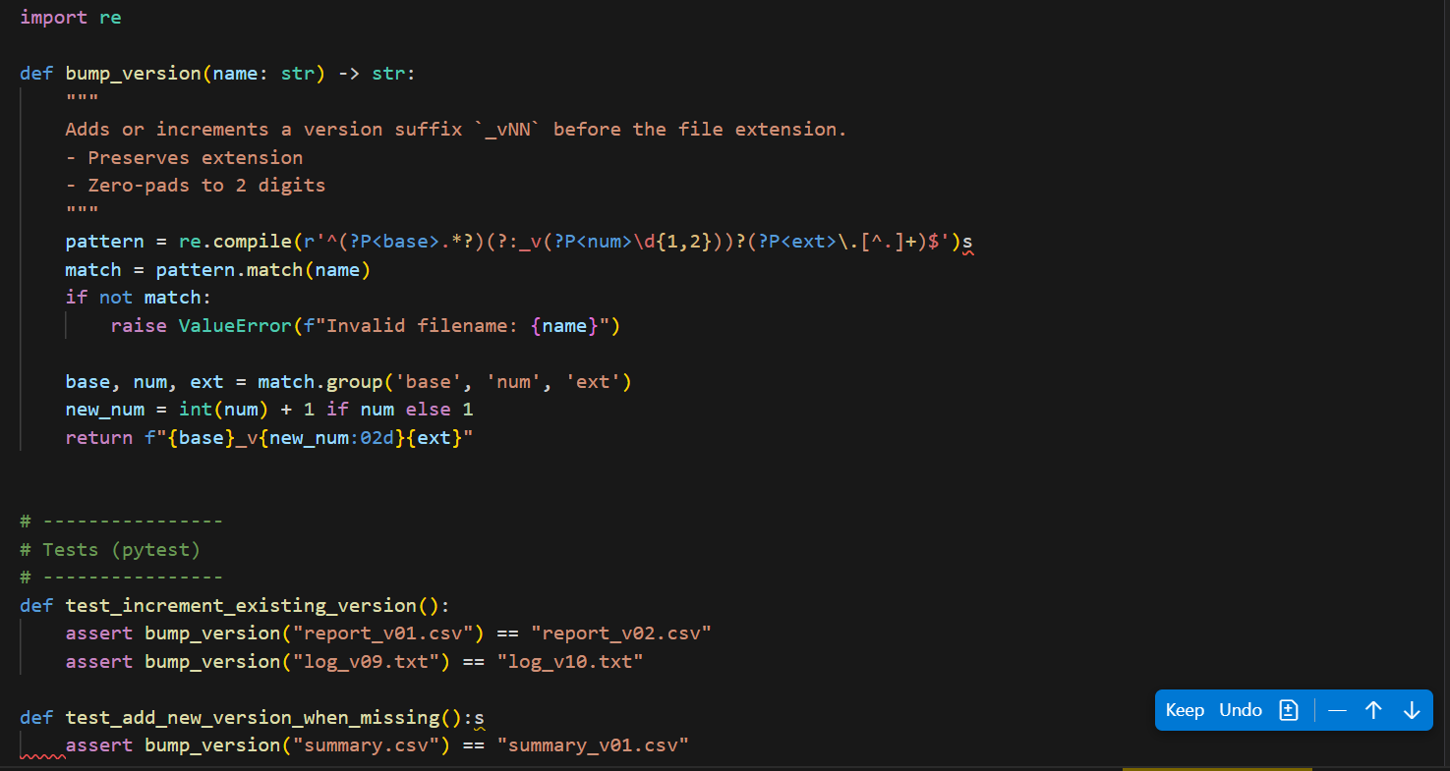

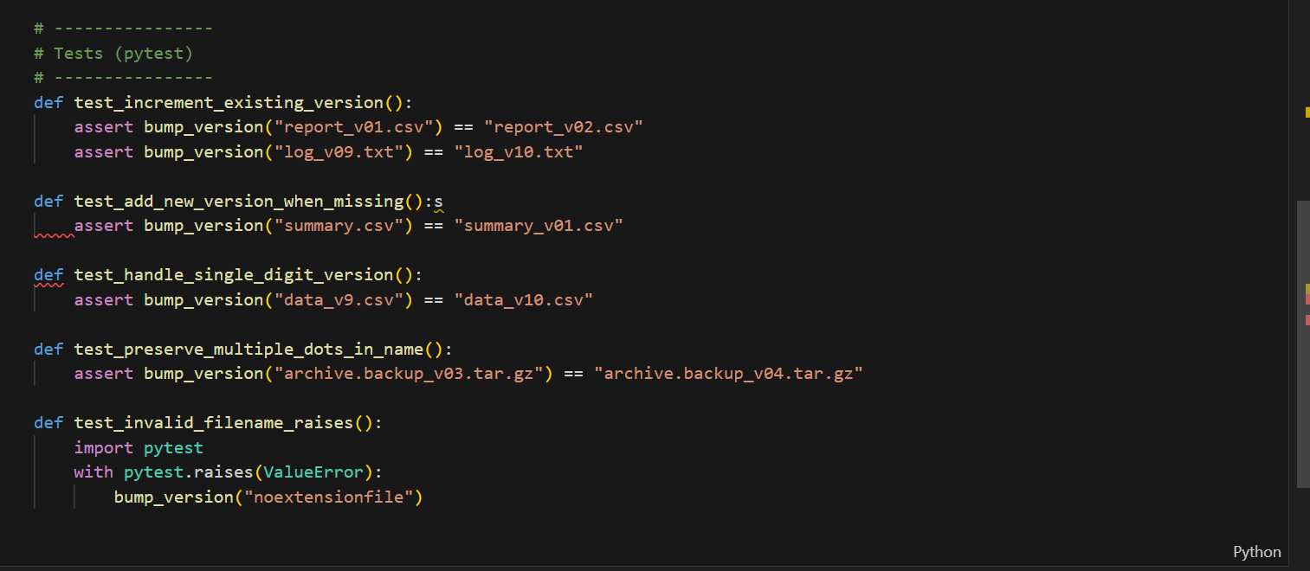

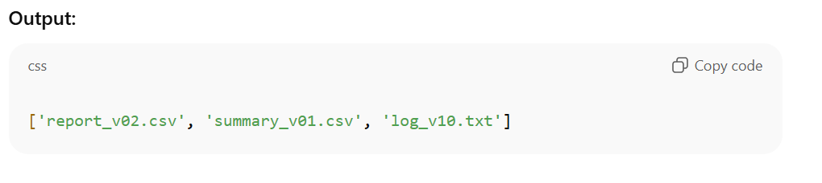

**Q)D2**

**Context:**

Analysts in real estate listings platform normalize metrics to [0,1].

**Task:**

Add docstrings and handle m==n case.

**Data & Edge Cases:**

Empty list -> []; uniform list -> all zeros

**Prompt:**

Generate for Google-style docstrings and edge-case tests.

